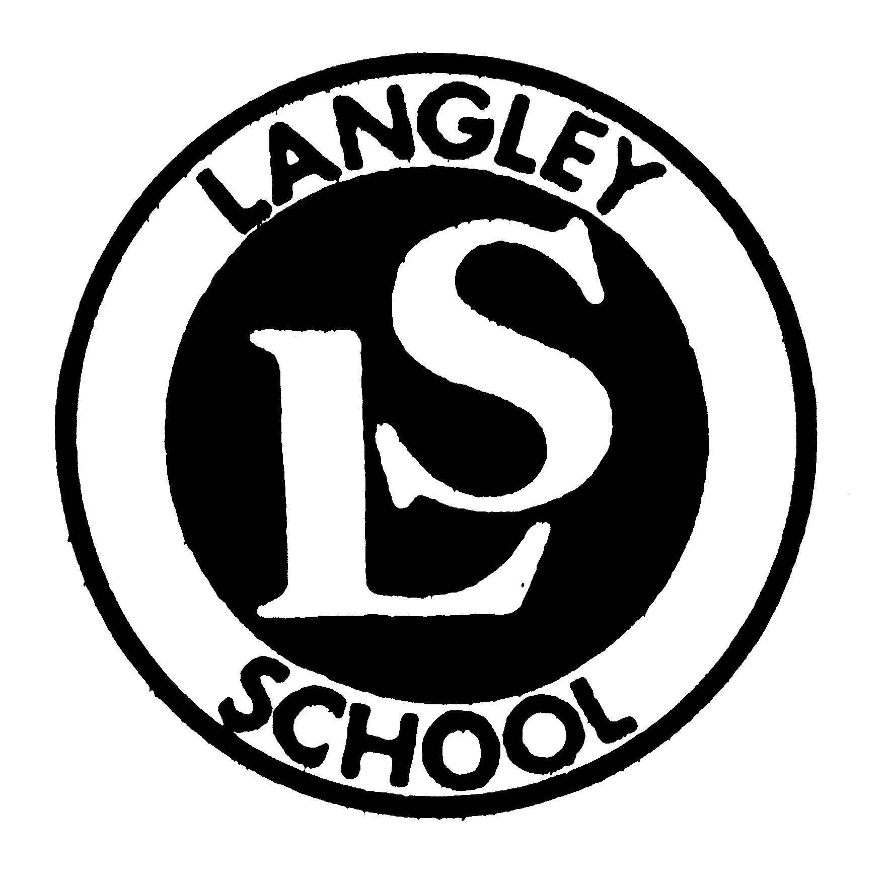 | BIRMINGHAM CITY COUNCIL - CHILDREN, YOUNG PEOPLE AND FAMILIES  Langley School  Trinity Road, Sutton Coldfield  West Midlands, B75 6TJ  www.langley.bham.sch.uk | Executive Head Teacher:  Jeanette Ashwin B.Sc., P.G.C.E.  Tel No: 0121 675 2929  Fax No: 0121 464 2180  e-mail: enquiry@langley.bham.sch.uk

14th December 2021

Dear All,
End of Term Newsletter

As we approach the end of another busy term I would like to thank all the staff for their hard work and dedication. It has been a pleasure, as ever, to work with such amazing children and they have continued to work hard and delight us in the progress they have made.
This term we have welcomed additional professionals into school. Our Speech and Language Therapists (Louise, Laura and Khavita) and our Occupational Therapist (Emma) have immersed themselves into Langley school life and have been working alongside the class staff to support the children.

Key Dates:
Spring Term starts: Tuesday 4 January 2022
Half Term: Monday 21 February 2022 to Friday 25 February 2022
Monday 28th February is a training day for the staff, school will be closed to pupils on this day.
Spring Term ends: Friday 8 April 2022

Coppice and Langley Club

The Spring term will also see the transfer of the before and after school care to Coppice and Langley. This will be known as the Coppice and Langley Club. It will continue to offer extra-curricular school activities, operating from 7.30am until school commences, and after school until 6.00pm. Provision is term time only, with holiday provision provided via JC Academy. There is the option of breakfast in the morning session, and snacks and drinks will be offered in the afternoon. Times and prices are as follows:

AM Option 1 7.30am-start of school £5.50 per session
AM Option 2 8.00am – start of school £4.00 per session
PM Option 1 end of school – 5.00pm £6.00 per session
PM Option 2 end of school – 5.30pm £9.00 per session
PM Option 3 end of school – 6.00pm £12.00 per session

Further detailed information is available by emailing coppiceandlangleyclub@coppice.bham.sch.uk and requesting an information pack. Alternatively, the registration form and booking is available on the Langley School website https://www.langley.bham.sch.uk/web/coppice_and_langley_after_school_club/586366

Severe Weather and School Closure
As we are now into our winter months may I also take this opportunity to remind you of the communication should we need to close the school in the event of severe weather. The school closure would be communicated on the School Website and on Radio WM and Free Radio. We will also endeavor to text you this information (please could you ensure we have your latest contact details to help with this).

Safeguarding
Langley is now an Operation Encompass school. This means we are equipped to support
your child should they be exposed to or involved in any domestic incident where the
police have been called.
Keeping your child safe online - As some children might be lucky to get new devices for Christmas, don’t forget to ensure parental controls are set up. If you need any help please contact us at school and we’ll be happy to support you with this.

COVID Update from Department for Education
From Tuesday 14 December, a new national approach to daily testing for contacts of COVID-19 is being introduced (including until the end of this term). All adults who are fully vaccinated and children aged 5 to 18 years and 6 months, identified as a contact of someone with COVID-19 – whether Omicron or not – should take a lateral flow device (LFD) test every day for 7 days instead of self-isolating. LFD test kits are available through the usual routes (community test sites, local pharmacies or online).

Once notified by NHS Test and Trace as a close contact, all eligible staff, pupils and students should take an LFD each day for 7 days and report the results through the Online Reporting System and to their setting. If they test negative, they can continue to attend their education setting. This approach should also be adopted over the winter break and on return in January.

If they test positive, they should self-isolate and order a PCR test to confirm the result. If the PCR is positive, they must self-isolate for 10 days. If the PCR test is negative, they no longer need to self-isolate but should continue to carry out the remainder of the daily tests, and only need to isolate if it is positive.

Children under five years old do not need to take part in daily testing for contacts of COVID-19 and do not need to isolate.

Festive Period
As we end term with festive celebrations, I would like to thank Dobbies for donating the Christmas Tree this year to Langley school. Santa has been in touch and will be visiting school on Thursday and we will also draw the raffle for the much sought-after Chocolate Hamper on this day.

Finally, I would like to wish you all a safe and peaceful Christmas and New Year period and I look forward to seeing the children back in school on Tuesday 4th Jan 2022.

With my very best wishes

Denise Fountain

(Interim Head Teacher – Langley School)

